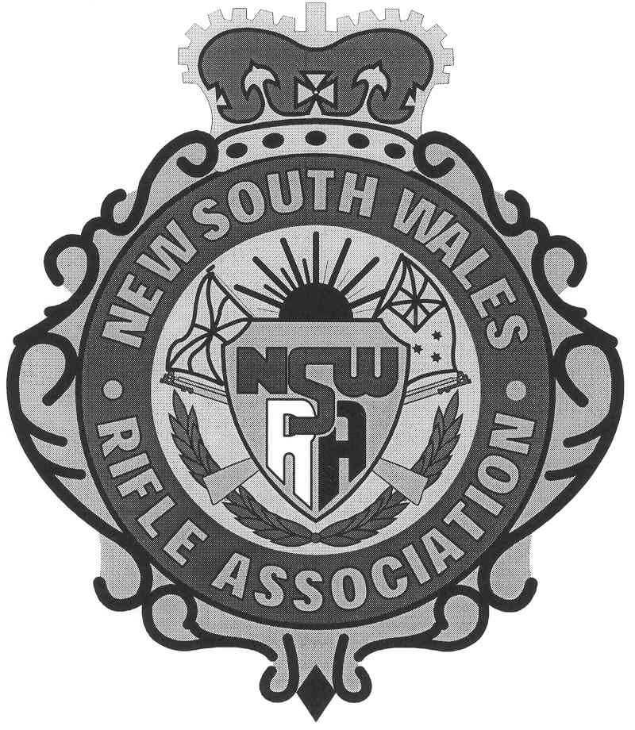Please accept my nomination for the

□ TARGET RIFLE

In the position (s) of □ Captain □ Wind Coach □ Manager □ Shooter

If nominations are emailed you should request Receipt of Delivery Acknowledgement.

Email: execofficer@nswra.org.au Fax: (02) 9661 6042 Post: PO Box 386, MAROUBRA NSW 2035

Surname ______________________ Given Names: ______________________________________

Street: ______________________ Suburb: ______________________ Postcode: _______

Phone: ____________ (Home) Work) ______________ Mobile) ______________________

Email address, if any ____________________________ Rifle Club: _________________________________

Team Members must be affiliated with the NRAA of Australia

ACHIEVEMENTS ONLY IN THE 3 YEARS PRIOR TO THE DATE OF THIS NOMINATION
This section has been divided into several specific parts - State Team Shooting; Australian Team Shooting; Other Team Shooting; Individual Results. If there is insufficient space for results, please attach a summary of additional information only for the previous 3 years. Do not include results from earlier than 3 years ago. .

Nominees for Wind Coach should enter scores of their shooters and/or squad for each range. Attach additional information if there is insufficient space.

STATE TEAM SHOOTING

Year | Event | Scores | Coach's name & any comments

AUSTRALIAN TEAM SHOOTING

Year | Event | Scores | Coach's name & any comments
Apart from the above State and Australian events in which many will not have participated therefore consideration will be taken into account of other team or personal performances.

OTHER TEAM SHOOTING (include State v Rest, Country v City, DRA and Coached Club Teams)
Year | Event | Scores | Coach's name & any comments

INDIVIDUAL NATIONAL AND STATE CHAMPIONSHIP RESULTS
Year | Event | Lead Up Score | Lead Up Place | Queen's Score | Queen's Place | Grand Score | Grand Place | Comments (if any)

PRIZE SHOOTS
Year | Event | Total | Place | Comments (If any)

Add other Club scores recorded on your home range ONLY if you have not attended many State Championships, DRA or Club Prize shoots in the past 3 years

CLUB SCORES
Year | Range Name | 300 | 500 | 600 | 700 | 800 | 900 | 1000

OTHER RELEVANT INFORMATION THAT YOU MAY WISH TO LIST IN SUPPORT OF YOUR NOMINATION:

Following selection by Council of the Captains, Wind Coaches and Manager, nominations for Shooters will be reviewed and a squad shall be selected.

Final Team Members will be required to abide by the NSWRA Code of Behaviour.

I have completed the above application truthfully to the best of my knowledge and ability.

Signature:______________________________________ Date:__________________

